

Semester One Examination, 2021
Question/Answer booklet

MATHEMATICS
METHODS
UNIT 1
Section One:
Calculator-free

Your name

Teacher (please circle) HILL PECK

Time allowed for this section
Reading time before commencing work: five minutes
Working time: fifty minutes

Materials required/recommended for this section
To be provided by the supervisor
This Question/Answer booklet
Formula sheet

To be provided by the candidate
Standard items: pens (blue/black preferred), pencils (including coloured), sharpener,
correction fluid/tape, eraser, ruler, highlighters

Special items: nil

Important note to candidates
No other items may be taken into the examination room. It is your responsibility to ensure that you do not have any unauthorised material. If you have any unauthorised material with you, hand it to the supervisor before reading any further.

Structure of this paper

Section | Number of  questions  available | Number of  questions to  be answered | Working  time  (minutes) | Marks  available | Percentage  of  examination
Section One:  Calculator-free | 8 | 8 | 50 | 52 | 35
Section Two:  Calculator-assumed | 13 | 13 | 100 | 98 | 65
 |  |  |  | Total | 100

Markers use only
Question | Maximum | Mark
1 | 6
2 | 7
3 | 6
4 | 7
5 | 7
6 | 6
7 | 7
8 | 6
S1 Total | 52
S1 Wt (×0.6731) | 35%
S2 Wt | 65%
Total | 100%

Instructions to candidates

1. The rules for the conduct of examinations are detailed in the school handbook. Sitting this examination implies that you agree to abide by these rules.

2. Write your answers in this Question/Answer booklet preferably using a blue/black pen.
Do not use erasable or gel pens.

3. You must be careful to confine your answers to the specific question asked and to follow any instructions that are specific to a particular question.

4. Show all your working clearly. Your working should be in sufficient detail to allow your answers to be checked readily and for marks to be awarded for reasoning. Incorrect answers given without supporting reasoning cannot be allocated any marks. For any question or part question worth more than two marks, valid working or justification is required to receive full marks. If you repeat any question, ensure that you cancel the answer you do not wish to have marked.

5. It is recommended that you do not use pencil, except in diagrams.

6. Supplementary pages for planning/continuing your answers to questions are provided at the end of this Question/Answer booklet. If you use these pages to continue an answer, indicate at the original answer where the answer is continued, i.e. give the page number.

7. The Formula sheet is not to be handed in with your Question/Answer booklet.
Section One: Calculator-free 35% (52 Marks)
This section has eight questions. Answer all questions. Write your answers in the spaces provided.

Working time: 50 minutes.

Question 1 (6 marks)
Solve the following equations for $x$.

(a) $\left(2x+5\right)\left(x-4\right)=0$. (2 marks)

(b) $x^{2}-10x-11=0$. (2 marks)

(c) ${\left(x-8\right)}^{2}-100=0$. (2 marks)

Question 2 (7 marks)
Consider the function $f\left(x\right)=\begin{matrix}p \\ \overline{x+q}\end{matrix}$ , where $p$ and $q$ are constants. The graph of $y=f(x)$ has an asymptote with equation $x=2$ and passes through the point $(6, -1)$.

(a) Determine the value of $p$ and the value of $q$. (3 marks)

(b) State the equation of the other asymptote of the graph of $y=f(x)$. (1 mark)

(c) Sketch the graph of $y=f(x)$ on the axes below. (3 marks)
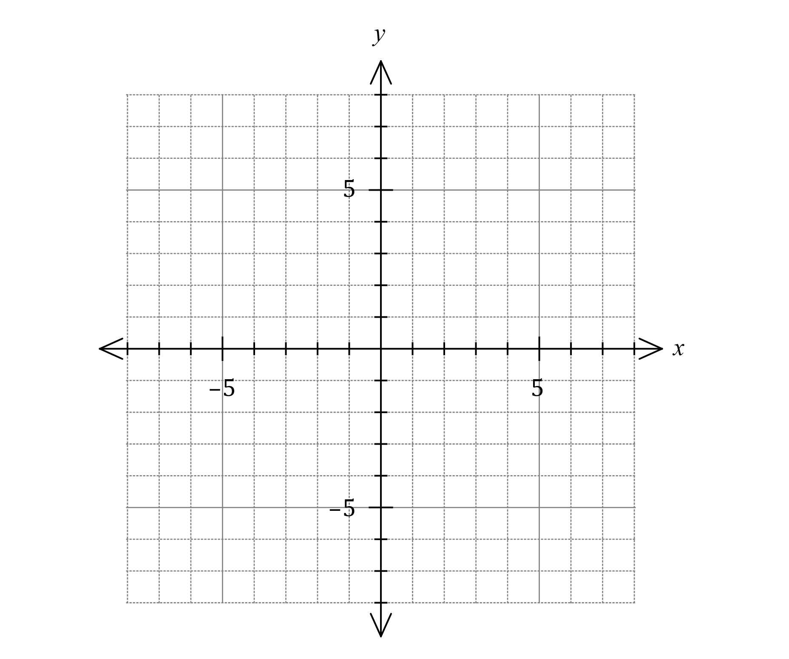

Question 3 (6 marks)
(a) The graph of $y=a\sin{(x+b)}$ is shown below, where $a$ and $b$ are positive constants.
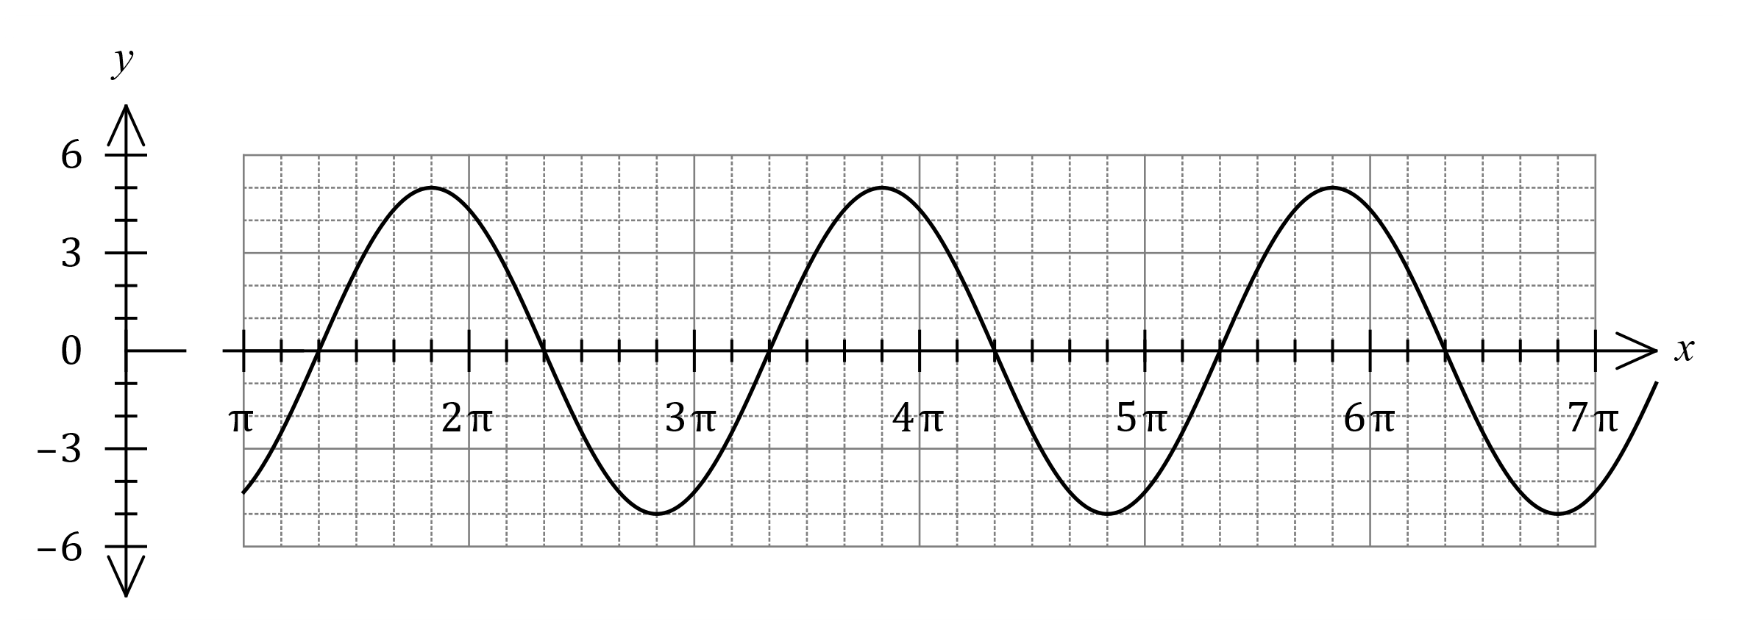
Determine the value of $a$ and the least value of $b$. (2 marks)

(b) Let $f\left(x\right)=4\tan\left(x-\begin{matrix}π \\ \overline{6}\end{matrix}\right)$.
Determine the x-intercepts of the graph of $y=f(x)$ for $0≤x≤2π$. (2 marks)

(c) Let $g\left(x\right)=3+\cos\left(\begin{matrix}x \\ \overline{2}\end{matrix}\right)$.

Determine the coordinates of the minimum of the graph of $y=g(x)$ for $0≤x≤4π$.
(2 marks)

Question 4 (7 marks)
The straight line $L$ has equation $3x-2y=1$.

(a) Write the equation of $L$ in the form $y=mx+c$ to show that its gradient is $1.5$. (1 mark)

Line $L_{1}$ is parallel to $L$ and passes through the point $(2, -3)$.

Line $L_{2}$ is perpendicular to $L$ and passes through the point $(9, 1)$.

(b) Determine the point of intersection of $L_{1}$ and $L_{2}$. (6 marks)

Question 5 (7 marks)
(a) In a right triangle, one angle measures x°, where 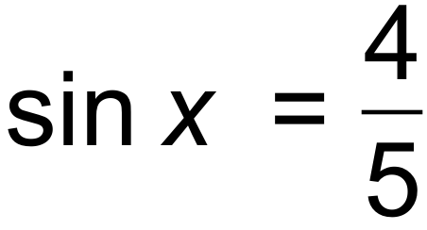.
State the value of 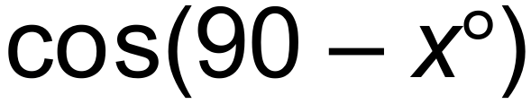. (1 mark)

(b) Solve the equation 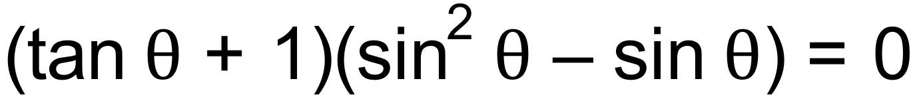 for 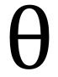, given that 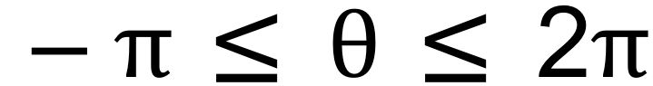. (3 marks)

(c) By using the appropriate addition formula find the exact value of 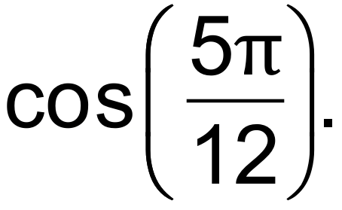 (3 marks)

Question 6 (6 marks)
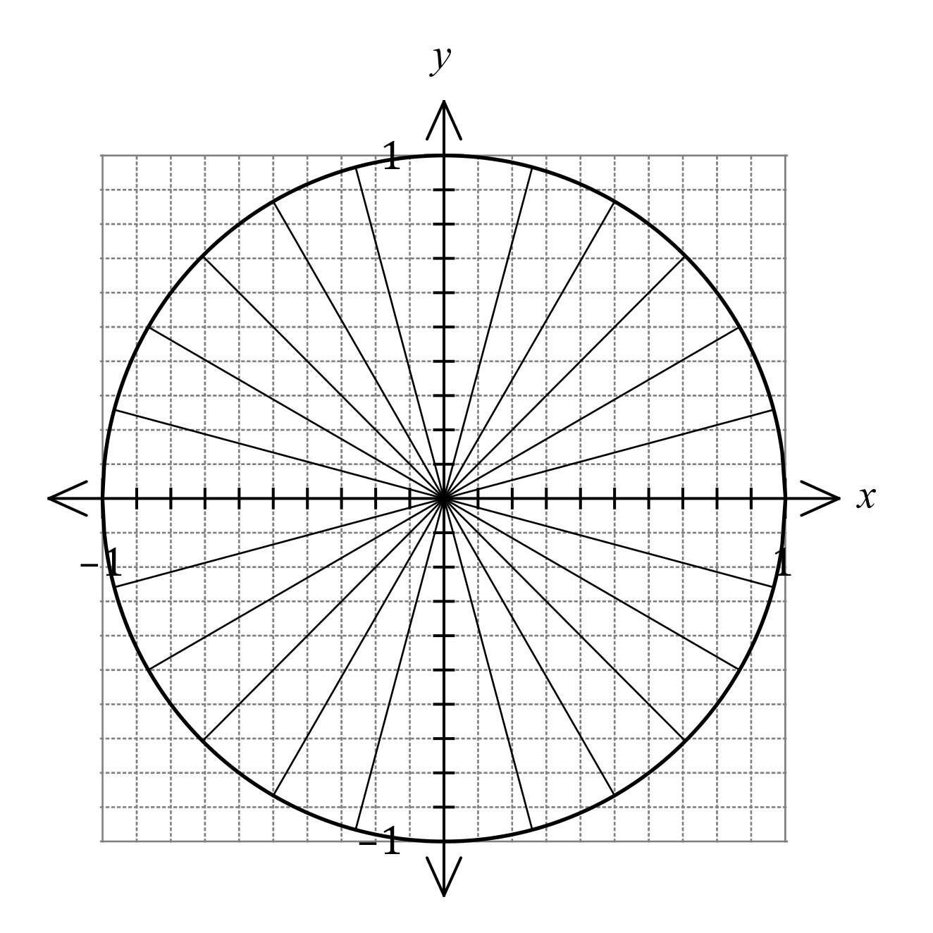
(a) A unit circle is shown.
Mark on the circumference of the
circle the points A and B so that
rays drawn from the origin to each
point make anti-clockwise angles
of $165°$ and $\begin{matrix}13π \\ \overline{ 12 }\end{matrix}$ from the positive
$x$-axis respectively.
Hence estimate the value of $\cos{165°}$
and the value of $\sin\left(\begin{matrix}13π \\ \overline{ 12 }\end{matrix}\right)$.

(3 marks)

(b) Solve the equation $3\tan{(2x-10°)}=\sqrt{3}$ for $0°≤x≤180°$. (3 marks)

Question 7 (7 marks)
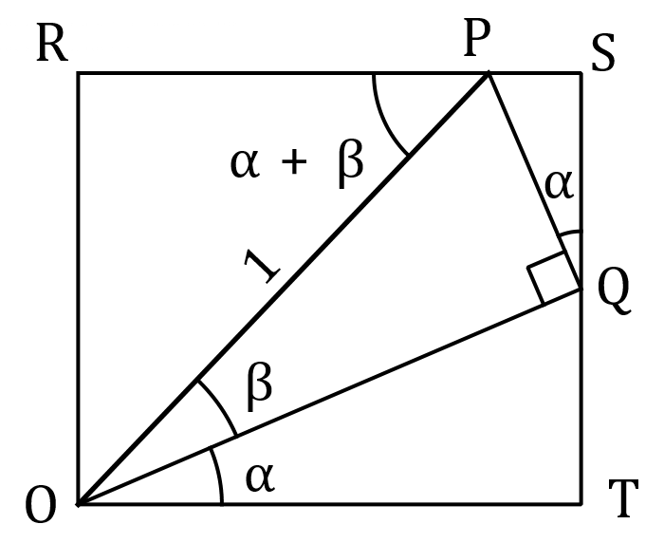
Consider rectangle $ORST$ that
contains the right triangle $OPQ$
as shown.

Let the length of $OP=1,∠QOT=∠SQP=α,$ $∠POQ=β$ and
$∠OPR=α+β$.

(a) Explain why $QT=\sin{α}\cos{β}$. (2 marks)

(b) Determine expressions for the lengths of $QS$ and $OR$ and hence prove the angle sum identity $\sin{(α+β)}=\sin{α}\cos{β}+\cos{α}\sin{β}$. (3 marks)

(c) Use the identity from part (b) to show that $\sin\left(x+\begin{matrix}3π \\ \overline{ 2 }\end{matrix}\right)=-\cos{x}$. (2 marks)

Question 8 (6 marks)
Two polynomial functions are defined by $f\left(x\right)=(3x-2)(x+4)$ and $g\left(x\right)=x^{3}-x^{2}+3x+2$.

Determine the coordinates of the point(s) of intersection of $f(x)$ and $g(x)$.

Supplementary page

Question number: _________

© 2021 WA Exam Papers. Kennedy Baptist College has a non-exclusive licence to copy and communicate this document for non-commercial, educational use within the school. No other copying, communication or use is permitted without the express written permission of WA Exam Papers. SN245-172-1.

